**Chapter IV**

**PRESENTATION, ANALYSIS AND INTERPRETATION**

This chapter will discuss the presentation, analysis, and interpretation of data corresponding to the research study stated at the beginning of the study. This is accomplished so that small data are shown. All the graphs, studies and other data that provides the study to strengthen the ideas below.

**4.1 Developing the Existing System to the Proposed System**

**Context Diagram of the Existing System**

Some e-commerce site like wix.com, wordpress, they provide e-commerce template or personal template but it don’t have a database algorithm to manage all the information for sorting, merging, communication on different modules and become fully dynamic. The diagram below shows how their e-commerce template works.



**Context Diagram of the Proposed System**

The proposed system of the proponents has 3 users: Administrator for the distributing, monitoring the reports and transaction. Customers for the ordering, transaction, contacting the developers. Agent for the updating the product if they have new product all monitor the product and the order of the customer. The system can enhance in terms of payment, geographical location of the customer, less security provision and the accurateness of the product management. The diagram below shows the proposed system of the proponents.





1. **Features of Management System for Food E-Commerce with PayPal Integration and Database Algorithms**
2. There are three (3) main modules of the main website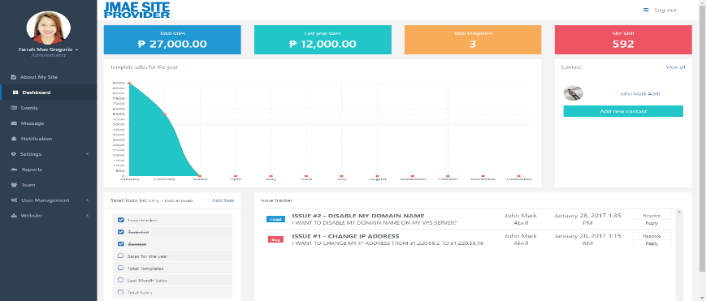  
   Server side – Administrator manage the entire website.  
     
     
   Guest Side – The user doesn’t have an account.

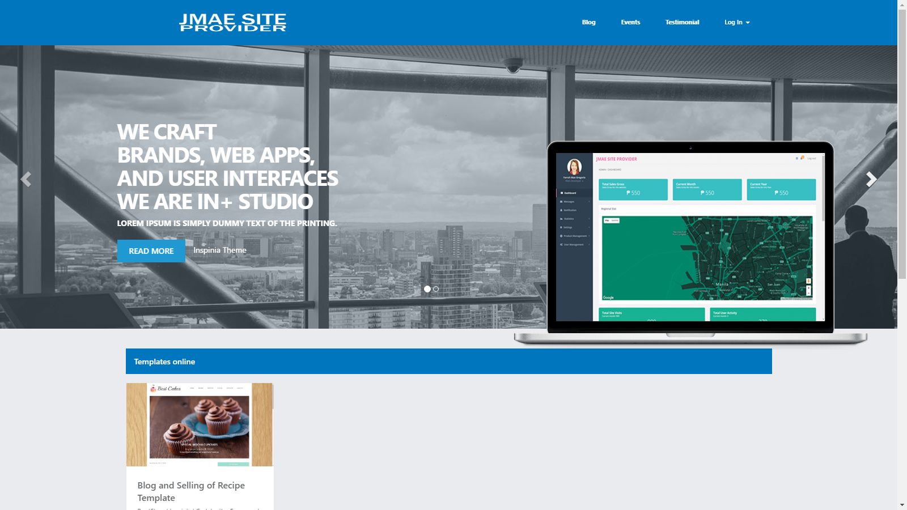

1. PayPal Integration

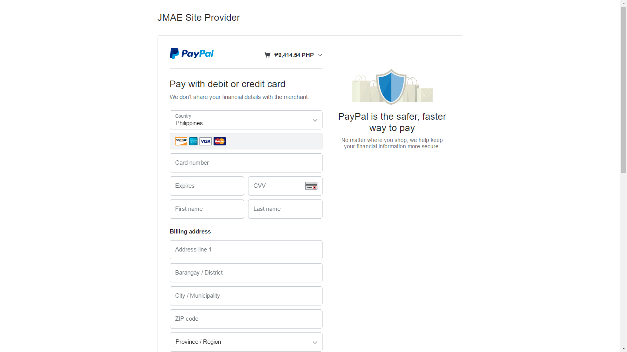

The client can be paid the purchased template through PayPal without difficulty and more secured.

1. Account Verification both template and main website

In the process of creation of an account it has a verification through web mail services.

1. Purchasing a template uploaded to the web server
2. Purchased template can manage and operate by administrator (client)

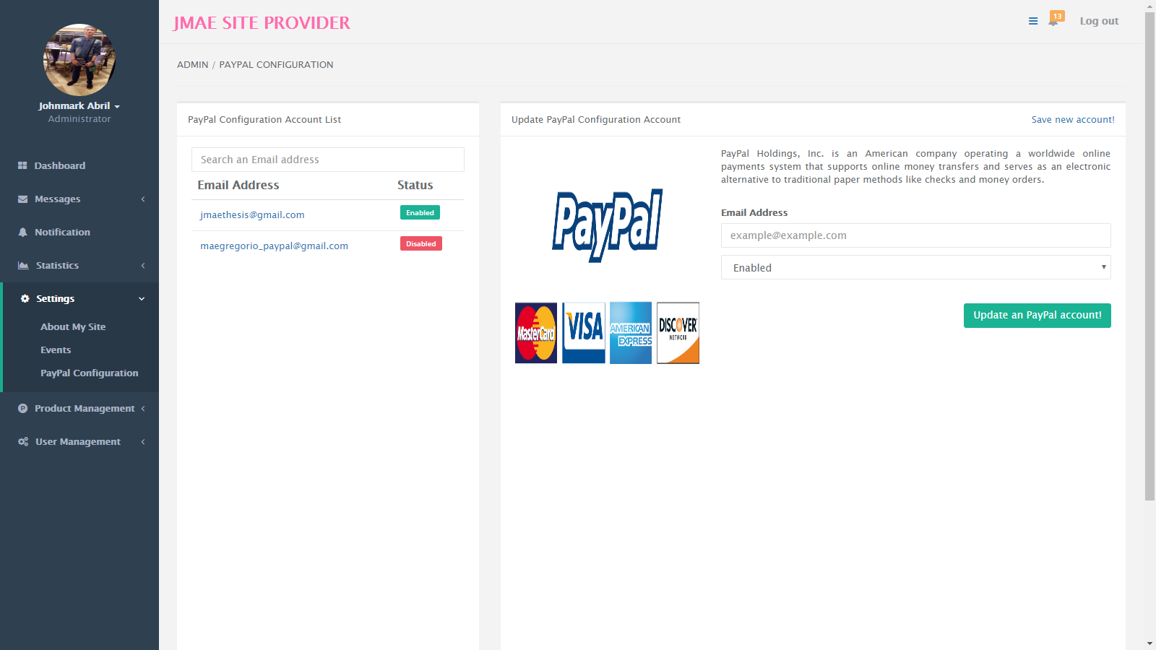

Client can manage and operate its template by updating the file in the content management system feature.

1. Database Algorithm

The system includes database algorithm for better and to optimize the processing of information from the database.

1. Securing the account of client
2. Main system has an agent side
3. There are two (2) main module in the template

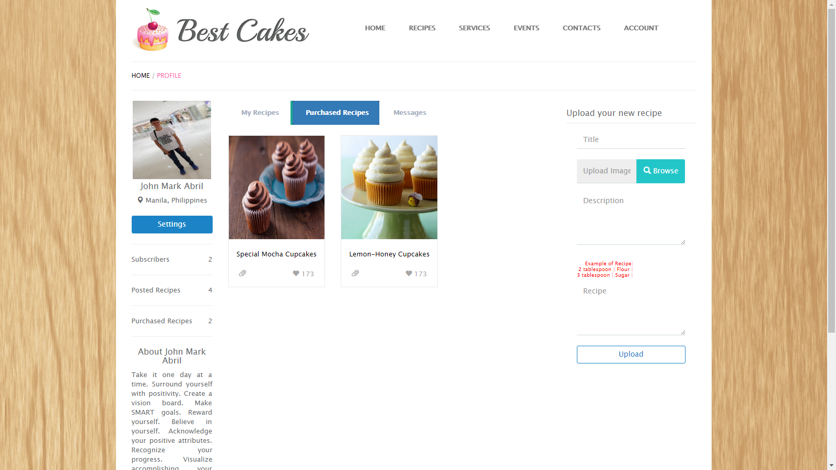

The client/customer side

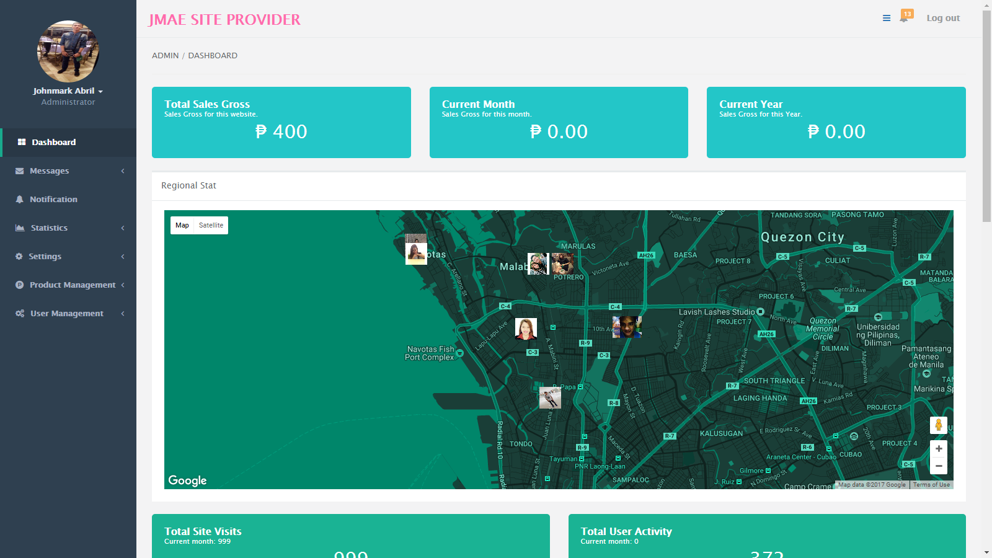

The server side

1. Administrator of client site

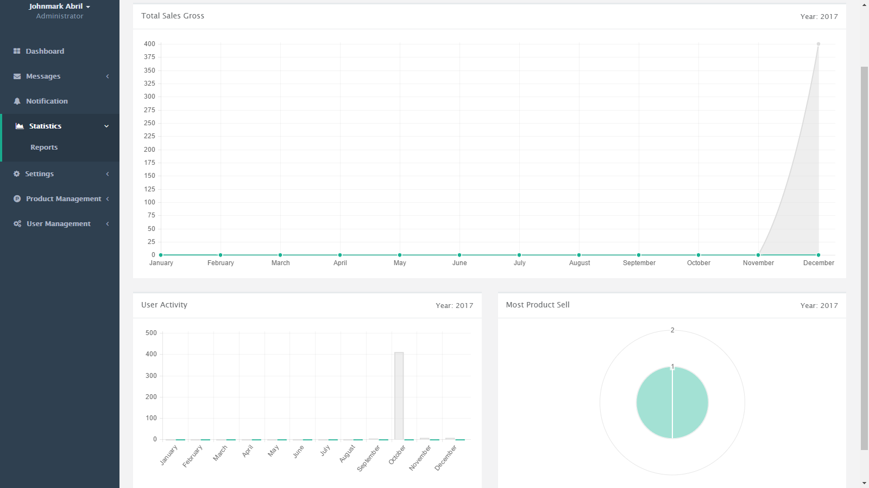

The administrator can distribute, monitor the reports and transaction.

1. Internet traffic issue

The system can handle many users without the internet traffic issue.

1. Administrators can add co-administrators or agent

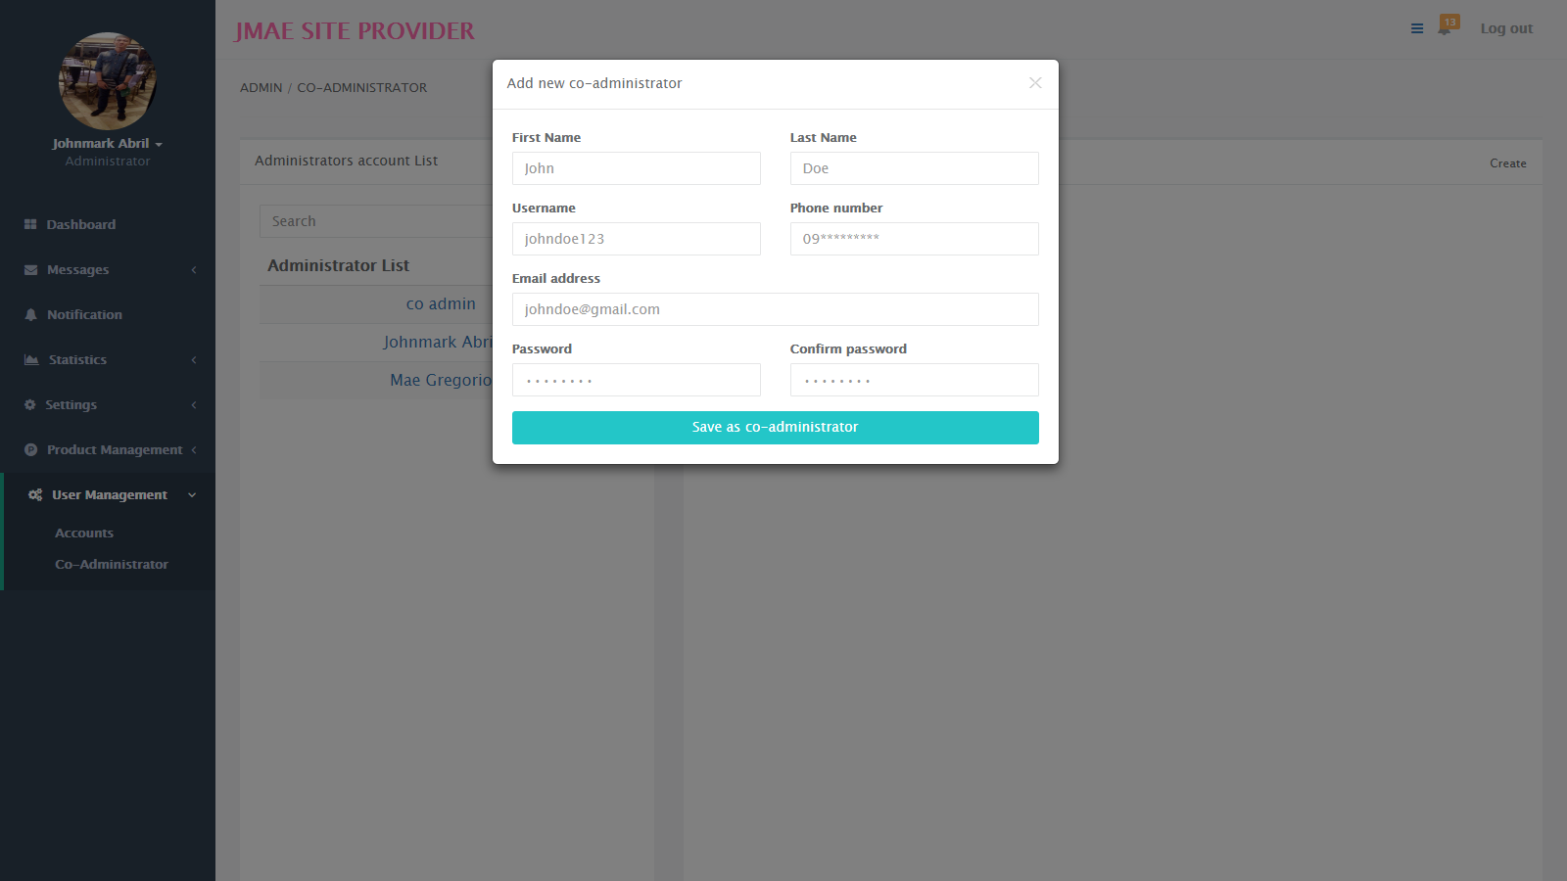

The administrators can add co-administrators or agent to help them to maintain their website.

1. Google map feature

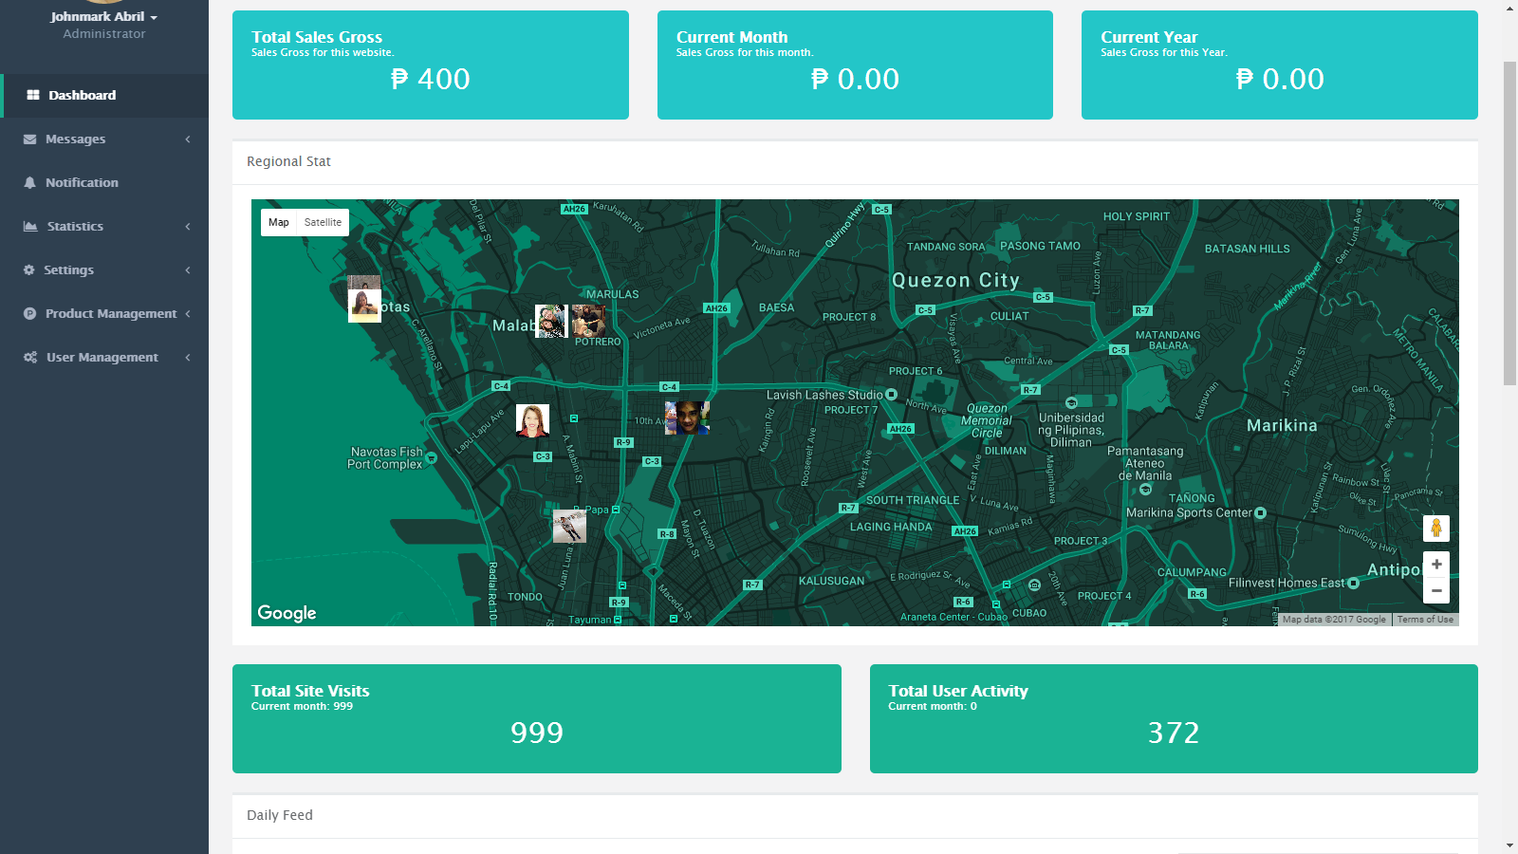

The system has a google map feature to see the customer and client address.

1. In the main website, client can add a template to the cart.
2. **Estimated Cost**

|  |  |
| --- | --- |
| ITEM | COST |
| Web Domain | ₱ 12.50 |
| Web Hosting | ₱ 1,462.50 |
| Web Server | ₱ 429.00 |
| Total | ₱ 1,904.00 |

1. **Performance of the system according to:**
2. **Accuracy**

In terms of accuracy, management system for food e-commerce with PayPal integration and database algorithm have a great accuracy for transporting different amount of data to a specific module. Our system operate all the information and transport the specific information to the specific account or user.

1. **Productivity**
2. **Security**

In terms of security, our system provides a great security for keeping the files and account secured. We the proponents use hashing for keeping the password and other information more secured. The signup process has a confirmation code thru email for verifying if the person is real or a bot, in order to do that we use SMTP for sending mail to different web mail services like GMAIL, YAHOO, etc. The account cannot open, if the account is open. In administrator module the permission is another algorithm to keep some sub-module become more restricted to other administrator.

**Project Development Process**

The proponents use Waterfall model as a guide to the fulfillment of the project. The diagram below shows the systematic procedure that proponents followed.

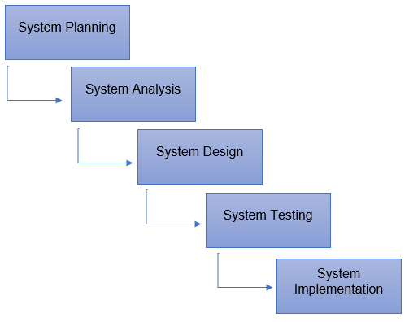

**System Planning and Analysis.**

In this phase, the proponents gathered data that needed in their system like as software requirements, hardware requirements and the idea in terms of e-commerce. They analyzed. Before the proponents starts the actual coding, they need to understand the requirements of the client side design and user, and the finished product look like.

**System Design**

After the planning and analyzing part, the design helps in indicating software and hardware requirements, and it helps the overall system planning. The proponents study an UI/UX for the better graphical user interface. They create algorithm to make Management System for Food E-Commerce with PayPal Integration and Database Algorithm run faster in different web browser.

**System Testing and Implementation**

The work split in different modules and the actual coding must start. The small part is called modules, modules are tested and developed for its functionality. And integrated all modules to the implementation. The proponents test their system in hard ways like security, files accessing, bunch of data, simultaneously use of website, text field expression and image upload. And in the implementation, they upload the website and template to the web server. They make their website more accessible.

**Flowchart**

The flowchart below illustrates the sequential order of a process needed to perform by the proponents. Each step in the sequential order is recognized within diagram shape. Sequential order is associated by connecting lines with directional arrows. This allows everyone to prospect the entire flowchart of the proposed system.

**4.2 Project Structure**

**HIPO Chart (Hierarchy plus Input-Process-Output)**

The illustrations below show the entire blueprint of the system including the hierarchy chart that strongly represents the system’s control structure and screenshots of every page of the website.

**Screenshots**

**4.3 Tabulating Results from the Proposed System**

**Project Evaluation**

The result of the respondent’s feedback to a given questions.